LONDON ORCHID SOCIETY
2024 Orchid Show Schedule

.
President Catherine McInerney
Vice President
Secretary
Treasurer Jeff Crawford

Show Committee

Show Chair: Show Floor Manager:

Sean Moore Sean Moore
145 Dreaney Ave
London, Ontario
N5Z 1W9
Phone: 519 645-7747
Email: spmoore@rogers.com

Show Secretary
Treasurer Jeff Crawford
Ticket Sales Catherine McInerney
Judging Convenor Sean Moore
Registration…………………………………………………Sean Moore
L.O.S. Display Catherine McInerney
Hospitality Justine Patterson, Ann Bacon
Publicity Daryl Bycraft
Orchids in Use Daryl Bycraft
Raffle Vito Debellis
A.O.S. Photographer Doug Blackshaw
Membership Jon Day
Note: Please send or phone your request for Exhibit or Sales space plus fees to the Show Floor Manager

SCHEDULE OF EVENTS

Friday, March 15, 2024 - Set-up 1:00 p.m. - 9:00 p.m.
- Registration 1:00 p.m. - 8:00 p.m.

(No registration tags will be accepted after 8:00 p.m. as the computer will close down at 8:00 p.m. However, advance registration sheets will be emailed out, if requested.)

Saturday, March 16, 2024 - Judging 8:00 a.m. - 12:00 p.m.
- Show Open to Public 12:00 p.m. - 5:00 p.m.

Sunday, March 17, 2024 - Photographers & Artists only 8:00 a.m. - 10:00 a.m.
- Show open to public 10:00 a.m. - 4:00 p.m.

Admission: $6.00 per person (Advance)
$8.00 per person (At the door)
$6.00 for seniors

SPECIAL AWARDS

A. To be awarded by AOS judges

1. A.O.S. Show Trophy:
Awarded to the Most Outstanding Display at the discretion of the judges.

2. Best of Show Award:
Awarded to the most outstanding orchid bloom, or blooming plant, in show.

B. To be awarded by Orchids in Use judge

- Canadian Orchid Congress Trophy:
Awarded to the Display showing the most artistic merit.

SHOW RULES AND REGULATIONS

EXHIBITION GUIDELINES

- Each exhibitor agrees upon making an entry to abide by the rules and regulations of the show.
- All questions regarding the interpretation or application of the rules shall be referred to the Show Committee. Their decision shall be final.
- All plants or cut flowers exhibited for competition must be properly labeled without the name of the owner visible until judging is completed.
- All plants and cut flowers must be officially entered by class with the Registrars. Cut flowers and flowering plants will be considered equally in judging. No dyed flowers will be permitted.
- In the event the exhibitor of cut flowers cannot be present; the Show Committee will display the material to the best advantage. If return of material is requested it will be returned at the exhibitor's expense. All exhibits not claimed by the exhibitor, or the disposal of which is not specified, will be distributed by the Show Committee.
- The London Orchid Society is not responsible for the loss or damage of any plants, blooms, containers or other property of exhibitors. However, precautions for their safety will be exercised.
- Foliage plants, moss etc. may be used, but no artificial plants or foliage, except artificial grass for ground cover.
- Display tables will be provided without cost if requested in advance.
- All cards displaying exhibitors' names will be provided by the London Orchid Society and will be placed after judging.
- All permanent lighting in the display area will be adjusted by the Manager after all exhibits are in place. Any lighting supplied by the exhibitor is the responsibility of the exhibitor and must be coordinated with the Show Committee. This lighting may be turned off by the judges during judging. The London Orchid Society will not be responsible for any damage to exhibitor's light fixtures.
- Commercial persons who wish to sell their products during the show must enter an exhibit including flowering plants.
- Any DISEASED or INFECTED plant will be barred from entry and must be IMMEDIATELY removed from the exhibit hall.
- Displays may be exhibited in only one class
14. No entries shall be removed from a display until 4:00 p.m. take down time.

EXHIBITORS' PROCEDURES & RESPONSIBILITIES

- A separate entry must be made for each plant, cut flower, arrangement and exhibit.
- Print legibly on the entry form.
- Procedure for entries

  - Obtain an EXHIBIT number from the registration desk. This is the number of your designated area.
  - Obtain an EXHIBITOR number from the registration desk. This will allow crediting of any awards to the correct individual. Exhibits of plants from many individuals may have separate numbers for each and/or a single number for the exhibit.
  - On the entry form, indicate the CLASS NUMBER for each entry. Check the show schedule for the correct class. It is your responsibility to classify entries correctly. Incorrectly entered entries may be moved or disqualified at the judge's discretion. If you are unsure of which class to use, ask at the registration desk for assistance.
  - Under NAME indicate the name of the plant, flower or exhibit. If the plant is an unregistered hybrid indicate the parentage in the space for the cross. If the entry is an exhibit, write the "theme" name of the exhibit if there is one, or just "Exhibit" if there is no theme.
  - Return completed entry form to the registration desk. Each entry will receive an ENTRY NUMBER. When completed, the tags will be issued to be placed on the plant, flower or exhibit.
  - All entry tags must be removed from all exhibits when judging is complete and before the show is opened to the public.

WHEN IN DOUBT, ASK FOR HELP!!!

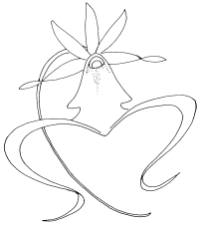

The current Mid-America class list for genera along with other references to assist you will be available at the registration desk.
CLASSIFICATION

- Decision as to the proper category of entry shall be the responsibility of the exhibitor. Improperly entered plants/exhibits may be reclassified or disqualified at the discretion of the judges. When exhibitors are unable to attend or designate the classes themselves, the Show Committee will use its own judgment, and its' decision will be final.
- Plants registered for a cultural award must have been in the possession of the exhibitor for at least one year prior to the show.
- An individual plant or cut flower cannot be registered in more than one class -- except where the second entry is in Class 101. In the event of a double entry, where the exhibitor has not indicated the preferred class to the judges, the entries disqualify each other.
- A meristem or keiki may not be entered as a seedling blooming for the first time.
- "HYBRID" denotes a cross between two or more species within a genus. "INTERGENERIC" denotes a cross between two or more genera.
- For the purpose of this show, an amateur is defined as any person who has not sold more than a total of two hundred (200) plants and/or cut flowers in the last year.

JUDGING

- First, Second and Third place ribbons, Honorable Mention ribbons, and special awards will be awarded in each class at the discretion of the judges. They have the right to withhold any prize.
- Judges and Clerks are expected to familiarize themselves with the rules and regulations.
- For purposes of ribbon judging, a class may be subdivided at the discretion of the judges.

NOTE: In addition to the ribbons and/or trophies awarded by the Show Committee, the judges may consider plants and flowers for American Orchid Society awards. Each person entering plants or flowers in the show agrees to accept any award given and to pay the American Orchid Society for such awards. If an entrant does not wish to accept and pay for the A.O.S. awards granted, this must be indicated before entering the plants for ribbon judging.

If the flowers have been previously exhibited at an A.O.S. approved function, they are considered to have been screened and, therefore, are not eligible for further consideration. They should be marked “NOT FOR AOS JUDGING”. This will not disqualify the flower from consideration in the appropriate ribbon or trophy class.

As a thank you to our exhibitors who bring their best plants for our show, L.O.S. will pay for all AOS awards granted at the March 16-17, 2024 L.O.S. show

AFTER THE JUDGING: Before removing entry tags, check them for judges' comments. Judges may write tips to help exhibitors improve the way the plant is exhibited in the future.
EXHIBITORS : Please --- Read the rules carefully !

DISPLAY CLASSES

A. Open Competition

1 - 3 Orchid plants in flower, arranged for effect
1. 1 to 10 orchid plants
2. 11 to 25 orchid plants
3. 26 or more orchid plants

4. Educational exhibits, no limitations.

AWARD - Rosette & Trophy - Best of Classes 1 through 4

B. Orchid Societies

5. Any number of orchid plants.

AWARD - Rosette & Trophy - Best of Class 5

C. Amateur Competition

6-9 .Orchid plants in flower, arranged for effect.
6. 1 to 5 orchid plants
7. 6 to 15 orchid plants
8. 16 or more orchid plants
9. Junior - Any size but for children up to and including 16
years of age.
Note: This class is to emphasize the junior exhibitor's ability to
create an orchid display. Orchid plants and other materials
may be obtained from any source (relatives, friends, etc.)
but the display must be created by the junior exhibitor
without help from anyone over the age of 16. Judges will
emphasize the display rather than the plants when judging
the exhibit.

AWARD - Rosette - Best of Classes 6-8
Rosette - Best of Class 9
Trophy - Best of Classes 6 Through 8

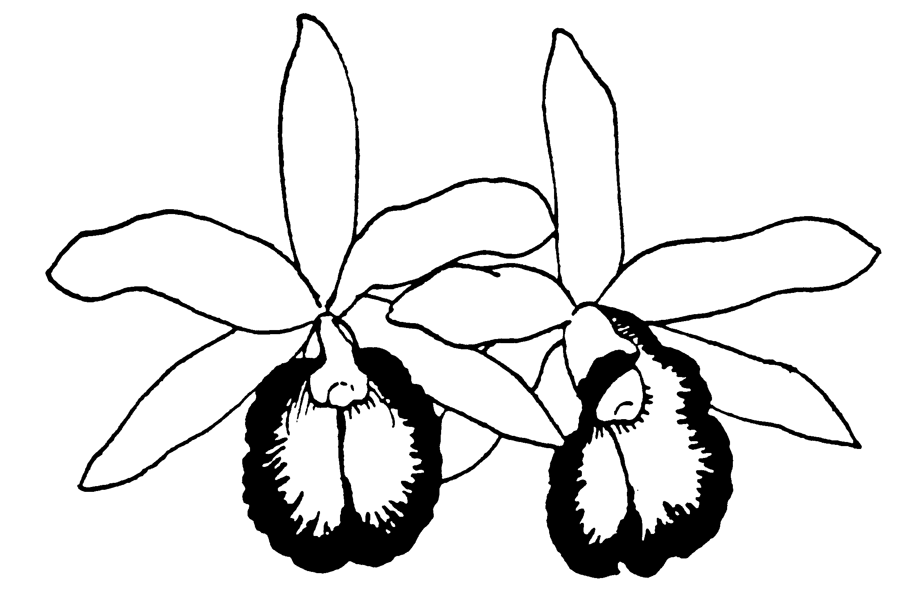

OPEN COMPETITION

Class No. CATTLEYA ALLIANCE

10. Encyclia, Epidendrum and Prosthechea species.
11. Encyclia, Epidendrum and Prosthechea hybrids and intergenerics, but excluding
Cattleya and Guarianthe.
12. Brassavola and Rhyncholaelia species, hybrids and intergenerics other than above but
excluding Cattleya and Guarianthe.
13. Broughtonia species, hybrids and intergenerics other than above, but excluding
Cattleya and Guarianthe.

AWARD - Rosette & Trophy - Best of Classes 10 through 13

15. Cattleya, Guarianthe, Laelia, Sophronitis species.
16. Cattleya allied genera species other than above
17. Cattleya and Guarianthe hybrids and intergenerics other than above – Lavender/Mauve, flowers less than10cm
18. Cattleya and Guarianthe hybrids and intergenerics other than above – Lavender/Mauve, flowers larger than 10cm
19. Cattleya and Guarianthe hybrids and intergenerics other than above - White
20. Cattleya and Guarianthe hybrids and intergenerics other than above – Semi-alba
21. Cattleya and Guarianthe hybrids and intergenerics other than above – Yellow, Orange, flowers less than 10cm
22. Cattleya and Guarianthe hybrids and intergenerics other than above – Yellow, Orange, flowers larger than 10cm
23. Cattleya and Guarianthe hybrids and intergenerics other than above, Red/Red shades,
flowers less than 10cm
23a Cattleya and Guarianthe hybrids and intergenerics other than above, Red/Red shades,
flowers larger than 10cm
24. Cattleya and Guarianthe hybrids and intergenerics other than above – Splash
Petal/other colours
25. Hybrids & intergenerics of genera allied to Cattleya & Guarianthe, other than above.
26. Miniature species, hybrids and intergeneric hybrids of Cattleya and allied genera and not entered in any of the previous classes. (total normal mature height of plant 25cm or less, excluding inflorescence)

AWARD - Rosette & Trophy - Best of Classes 15 through 26

Class No. CYPRIPEDIUM AND PAPHIOPEDILUM ALLIANCE

Colour in Paphiopedilum and Phragmipedium hybrids is based on the dominant colour of the flower

27. Paphiopedilum species – Parvisepalum and Brachypetalum sections
28. Paphiopedilum species – Insigne and Barbatum sections
29. Paphiopedilum species – Coryopedilum and Pardalopetalum sections (multifloral)
29a. Paphiopedilum species – Cochlopetalum section (sequentially flowering)
30. Paphiopedilum hybrids – brachy/parvi hybrids
31. Paphiopedilum hybrids – Maudiae, or cruciform type white/pink/green/yellow
32. Paphiopedilum hybrids – Maudiae or cruciform type other colors except vini colour
33. Paphiopedilum hybrids – hybrids multifloral
34. Paphiopedilum hybrids – hybrids sequential flowering
35. Paphiopedilum hybrids – full round shape, white/pink/green/yellow
36. Paphiopedilum hybrids – full round shape, other colors except vini colours
37. Paphiopedilum hybrids – vini colours

AWARD - Rosette & Trophy - Best of Classes 27 through 37

40a. Phragmipedium species – pink/red/yellow/orange, short petal types including besseae
and kovachii
40b. Phragmipedium species – green/brown, short petal types
40c. Phragmipedium species – long petal types
41a. Phragmipedium hybrids – pink/white
41b. Phragmipedium hybrids – red/yellow/orange (besseae or kovachii hybrids)
41c. Phragmipedium hybrids – green/brown, short petal types
41d. Phragmipedium hybrids – long petal types
42. Cypripedium alliance species, hybrids & intergenerics including allied genera other than above.

AWARD - Rosette & Trophy - Best of Classes 40a through 42

Class No. PHALAENOPSIS ALLIANCE

44. Doritis and Phalaenopsis species
45. Phalaenopsis hybrids – White –no markings, with or without coloured lip, flowers
less than 4cm
46. Phalaenopsis hybrids – White - no markings, with or without coloured lip,
flowers larger than 4cm.
47. Phalaenopsis hybrids – White - Spots/bars/blush/stripes - flowers less than 4cm
48. Phalaenopsis hybrids – White - Spots/bars/blush/stripes - flowers larger than 4cm
49. Phalaenopsis hybrids – Pink – with or without markings - Spots/bars/blush/stripes -
flowers less than 4cm
50. Phalaenopsis hybrids – Pink – with or without markings - Spots/bars/blush/stripes -
flowers larger than 4cm
51. Phalaenopsis hybrids – Yellow - with or without markings - Spots/bars/blush/stripes-
flowers less than 4cm
52. Phalaenopsis hybrids – Yellow -with or without markings-Spots/bars/blush/stripes-
flowers larger than 4cm.
53. Phalaenopsis hybrids – Other colours – with or without markings.

AWARD - Rosette & Trophy - Best of Classes 44 through 53

Class No. VANDA ALLIANCE

58. Aerangis species, hybrids and intergenerics
59. Angraecum, Aeranthes species, hybrids and intergenerics other than above
60. Vanda species formerly known as Neofinetia IN BLOOM (see 98a for plants w/o flowers)
60a. Vanda species other than above.
61. Vanda hybrids, Orange/Yellow, flowers less than 3.5cm
61a. Vanda hybrids, Orange/Yellow, flowers greater than 3.5cm
62. Vanda hybrids, Red/Pink, flowers less than 3.5cm
62a. Vanda hybrids, Red/Pink, flowers larger than 3.5cm
63. Vanda hybrids, Blue/Purple, flowers less than 3.5cm
63a. Vanda hybrids, Blue/Purple, flowers larger than 3.5cm
64. Vanda hybrids, other colours, flowers less than 3.5cm
64a. Vanda hybrids, other colours, flowers larger than 3.5cm
65. Rhynchostylis species, hybrids and intergenerics other than above.
66. Renanthera and Aerides species, hybrids and intergenerics other than above.
67 Vanda hybrids with species formerly known as Neofinetia IN BLOOM
68 Species of genera allied to Vanda other than above.
69. Hybrids and intergenerics allied to Vanda other than above.

AWARD - Rosette & Trophy - Best of Classes 58 through 69

Class No. ONCIDIUM ALLIANCE

NOTE: Oncidiums are classed based upon size not the ‘traditional’ groupings except for Brassia, Miltonia, Miltoniopsis and Tolumnia

70. Brassia species and hybrids
70a. Brassia intergenerics
71 Miltonia/Miltoniopsis species & hybrids
72. Miltonia/Miltoniopsis intergenerics other than above (including Colmanara)
73. Oncidium species and species of genera allied to Oncidium, except Tolumnia -
flowers less than. 2.5cm
73a. Oncidium species and species of genera allied to Oncidium , except Tolumnia -
flowers more than 2.5cm
74. Oncidium and genera allied to Oncidium, hybrids and intergenerics, except Tolumnia,
flowers less than 2.5cm
75. Oncidium and genera allied to Oncidium, hybrids and intergenerics, except Tolumnia,
flowers more than 2.5cm
76. Tolumnia (equitant Oncidium) species, hybrids and intergenerics.

AWARD - Rosette & Trophy - Best of Classes 70 through 76

Class No. CYMBIDIUM ALLIANCE

79. Cymbidium species
80. Cymbidium hybrids, flowers less than 7.5cm
80a Cymbidium hybrids, flowers larger than 7.5cm
81. Species, hybrids and intergenerics of genera allied to Cymbidium other than above

AWARD - Rosette & Trophy - Best of Classes 79 through 81

Class No. DENDROBIUM ALLIANCE

82. Dendrobium species - nobile type
83. Dendrobium species - phalaenopsis and antelope types
84. Dendrobium species – nigro-hirsute type
84a. Dendrobium species – other types
85. Dendrobium hybrids - nobile type
86. Dendrobium hybrids - phalaenopsis and antelope types
87. Dendrobium hybrids – nigrohirsute type
87a. Dendrobium hybrids – other types
88. Dendrobium allied species, hybrids and intergenerics other than above

AWARD - Rosette & Trophy - Best of Classes 82 through 88

Class No. PLEUROTHALLIS ALLIANCE

89. Masdevallia and Dracula species
90. Masdevallia and Dracula hybrids and intergenerics
91. Pleurothallis species, hybrids and intergenerics other than above
92. Pleurothallis allied genera species, hybrids and intergenerics except above

AWARD - Rosette & Trophy - Best of Classes 89 through 92

Class No. MISCELLANEOUS GENERA

93. Lycaste, Ida, Sudamerlycaste and Anguloa species, hybrids and intergenerics
94. Maxillaria species, hybrids and intergenerics other than above
95. Zygopetalum & allied genera species, hybrids & intergenerics except above
96. Catasetum, Cycnoches, Mormodes and allied genera species, hybrids and intergenerics
97. Bulbophyllum and allied genera species, hybrids and intergenerics
98a. Jewel orchids, with/without flowers
98b. Orchid species and hybrids grown for unusual foliage, without flowers
98c. Orchid species not covered elsewhere
99. Hybrids and intergenerics not covered elsewhere
100. Miniature species, hybrids and intergenerics, all classes except Cattleya and Allied genera as covered in Class 26 (only plants not entered elsewhere (except class 101) are eligible.)

NOTE: Miniature is defined as naturally occurring diminutive plants in
flower not exceeding 15cm in height excluding inflorescence.

AWARD - Rosette & Trophy - Best of Classes 93 through 100

101. Specimen plants - may be any entered plant whether or not registered in this class. (Plants entered in classes 10-100 and 102-103 may be entered an additional time in this class only)

AWARD - Rosette & Trophy - Best of Class 101
102. Seedling flowering for the first time. Plants entered in this class may not be entered in classes 10 through 100 or 103, but may be entered additionally in class 101.

AWARD - Rosette - Best of Class 102

103. Any genera and species grown under lights or on windowsills
(Not greenhouse grown)
(NOTE: Plants entered here may not be entered in any other class except 101)

AWARD - Rosette & Trophy - Best of Class 103

AWARD - Rosette & Trophy - Best in Show
- all entries in Classes 10 to 103 eligible

Class No. ORCHIDS IN USE

Amateur Competition

104. Small arrangements - Arrangement in any direction - not to exceed 10" including container.
105. Standard arrangements - Arrangement for end table to be viewed from one side, not to exceed 30" including container

NOTE:

- Exhibitors are limited to one entry per class unless space permits.
- These classes are limited to arrangements using fresh orchid flowers.
- Orchid Arrangements will be judged. Orchids must predominate. Other flowers, foliage and accessories are permitted in all classes of arrangements. No plastic or artificial flowers or foliage will be permitted in the arrangements. All orchids must be fresh but not necessarily grown by the exhibitor.

AWARD - Rosette & Trophy - Best of Classes 104 through 105

